Volatility correlation: USDJPY and USDCAD
Method 25 / daily |log returns| / rho_vol / Alpari D1 full available history (realized deferred)

Study setup
Logical pair: USDJPY , USDCAD
Broker symbols: USDJPY_i , USDCAD_i
Snapshot: 2026-11-03_majors_alpari_D1
Timeframe: D1
Matched return window: 1999-01-05 to 2026-11-02 (UTC bar dates)
Matched return count n: 7186
Dropped unfinished last bar dated 2026-11-03 UTC after a tick-volume check against the prior complete day.
Statistic: rho_vol = Corr(|log return_L|, |log return_R|)
rho_realized: not computed (no intraday buckets in this snapshot)
Complete matched rows (Excel): USDJPY-USDCAD_Vol_D1.xlsx
Complete matched rows (HTML table): USDJPY-USDCAD_Vol_D1_data.html

Method carried forward
Volatility correlation rho_vol = Corr(|x_t|, |y_t|) measures whether absolute daily log returns of close move together in size, regardless of sign. Quotes are not inverted. Same-sample signed Pearson r is a side check. The formula sheet also defines within-day realized correlation rho_realized,d from intraday buckets; this v001 uses the Alpari D1 snapshot only, so rho_realized is not computed (no intraday buckets). This is not causation and not a trading signal.

Results (headline)
rho_vol: 0.223844
Pearson r (signed): 0.027603
mean |USDJPY|: 0.00444943
mean |USDCAD|: 0.00373127
rho_realized: n/a (D1-only snapshot)

Conclusion
Headline rho_vol for USDJPY and USDCAD: 0.2238. Signed Pearson r = 0.0276. Mean |return|: 0.004449 (USDJPY), 0.003731 (USDCAD). rho_realized not computed (D1 snapshot has no intraday buckets). This is absolute-move co-movement, not a trading signal.

Charts
Daily closes

Daily log returns

Absolute returns scatter
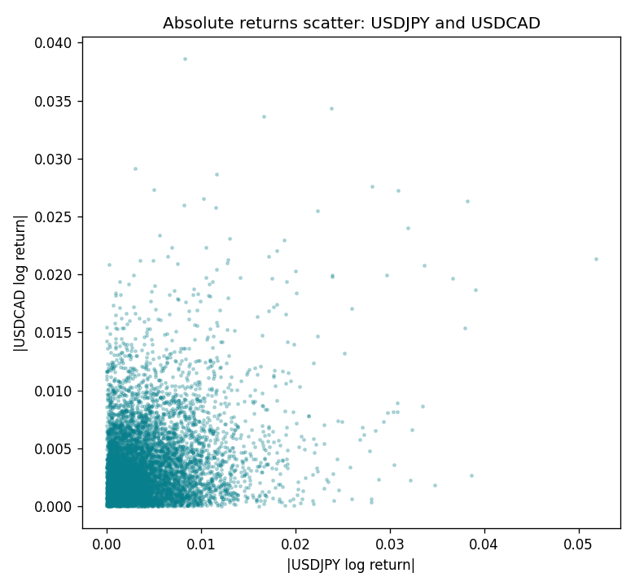

Data report
Matched rows are in the sibling Excel workbook named USDJPY-USDCAD_Vol_D1.xlsx. Embedding all rows as a Word table is impractical; this file holds column summaries and the first and last 15 matched rows.
Columns: time, USDJPY_open, USDCAD_open, USDJPY_high, USDCAD_high, USDJPY_low, USDCAD_low, USDJPY_close, USDCAD_close, USDJPY_tick_volume, USDCAD_tick_volume, USDJPY_spread, USDCAD_spread, USDJPY_real_volume, USDCAD_real_volume, USDJPY_log_return, USDCAD_log_return, USDJPY_abs_return, USDCAD_abs_return
Column summaries (matched calculation rows)
column | count | mean | std | min | 25% | 50% | 75% | max
USDJPY_open | 7186 | 113.80748 | 19.222412 | 75.693 | 104.39025 | 110.981 | 120.70625 | 163.824
USDCAD_open | 7186 | 1.266789 | 0.16892251 | 0.9168 | 1.118445 | 1.2985 | 1.37213 | 1.6183
USDJPY_high | 7186 | 114.30511 | 19.284087 | 76.001 | 104.8685 | 111.4395 | 121.2675 | 163.978
USDCAD_high | 7186 | 1.2716872 | 0.16888037 | 0.9336 | 1.122975 | 1.303895 | 1.37655 | 1.619
USDJPY_low | 7186 | 113.28446 | 19.150257 | 75.402 | 103.88 | 110.53 | 120.1715 | 163.628
USDCAD_low | 7186 | 1.2622311 | 0.16895752 | 0.9056 | 1.114125 | 1.293555 | 1.367815 | 1.6102
USDJPY_close | 7186 | 113.82065 | 19.237762 | 75.811 | 104.38275 | 111.018 | 120.69375 | 163.851
USDCAD_close | 7186 | 1.2668036 | 0.16889539 | 0.916 | 1.118165 | 1.29848 | 1.372395 | 1.6137
USDJPY_tick_volume | 7186 | 106329.64 | 179429.89 | 149 | 9948.5 | 53187 | 92874.5 | 1803508
USDCAD_tick_volume | 7186 | 81037.769 | 147318.12 | 37 | 5546.5 | 40944 | 71631 | 1410818
USDJPY_spread | 7186 | 20.270804 | 17.617829 | 0 | 6 | 11 | 30 | 50
USDCAD_spread | 7186 | 23.436682 | 18.263202 | 0 | 9 | 17 | 40 | 60
USDJPY_real_volume | 7186 | 3.4776211e+10 | 1.6092546e+11 | 0 | 0 | 0 | 0 | 3.8834203e+12
USDCAD_real_volume | 7186 | 1.8381818e+10 | 9.6701063e+10 | 0 | 0 | 0 | 0 | 2.5751613e+12
USDJPY_log_return | 7186 | 5.053e-05 | 0.00620694 | -0.03908203 | -0.00319936 | 0.00011986 | 0.0034094 | 0.05184024
USDCAD_log_return | 7186 | -1.555e-05 | 0.00514357 | -0.03859748 | -0.00283709 | 4.741e-05 | 0.00272359 | 0.03436319
USDJPY_abs_return | 7186 | 0.00444943 | 0.00432765 | 0 | 0.0014328 | 0.00330825 | 0.00619627 | 0.05184024
USDCAD_abs_return | 7186 | 0.00373127 | 0.00354009 | 0 | 0.00124222 | 0.0027938 | 0.00508486 | 0.03859748
First 15 matched rows (selected columns)
time | USDJPY_log_return | USDCAD_log_return | USDJPY_abs_return | USDCAD_abs_return
1999-01-05 | -0.00017868311 | -0.010131666 | 0.00017868311 | 0.010131666
1999-01-06 | 0.0075660159 | -0.0003306769 | 0.0075660159 | 0.0003306769
1999-01-07 | -0.012851583 | 0.0015202092 | 0.012851583 | 0.0015202092
1999-01-08 | -0.0047719894 | -0.0020495197 | 0.0047719894 | 0.0020495197
1999-01-11 | -0.016195423 | -0.0035137769 | 0.016195423 | 0.0035137769
1999-01-12 | 0.032310364 | 0.0066194721 | 0.032310364 | 0.0066194721
1999-01-13 | 0.0081373171 | 0.0045420214 | 0.0081373171 | 0.0045420214
1999-01-14 | 0 | 0.0069376546 | 0 | 0.0069376546
1999-01-15 | 0.0055343401 | -0.0056905671 | 0.0055343401 | 0.0056905671
1999-01-18 | 8.7600193e-05 | 0.00098344542 | 8.7600193e-05 | 0.00098344542
1999-01-19 | -0.0056219403 | 0.002748513 | 0.0056219403 | 0.002748513
1999-01-20 | -0.0053879917 | -0.0059646885 | 0.0053879917 | 0.0059646885
1999-01-21 | 0.0084664056 | -0.0042823796 | 0.0084664056 | 0.0042823796
1999-01-22 | 0.0060412564 | 0.0025057712 | 0.0060412564 | 0.0025057712
1999-01-25 | -0.0073594164 | 0.00085579808 | 0.0073594164 | 0.00085579808
Last 15 matched rows (selected columns)
time | USDJPY_log_return | USDCAD_log_return | USDJPY_abs_return | USDCAD_abs_return
2026-10-13 | -0.0018932826 | -0.0046395653 | 0.0018932826 | 0.0046395653
2026-10-14 | 7.5800166e-05 | 0.0015184751 | 7.5800166e-05 | 0.0015184751
2026-10-15 | -0.0018524319 | -0.0036101503 | 0.0018524319 | 0.0036101503
2026-10-16 | -0.00037976126 | -0.0034322068 | 0.00037976126 | 0.0034322068
2026-10-19 | 0.0034946841 | -0.0018835331 | 0.0034946841 | 0.0018835331
2026-10-20 | -0.0022546642 | -0.0037066008 | 0.0022546642 | 0.0037066008
2026-10-21 | -0.00032883504 | -0.00084691787 | 0.00032883504 | 0.00084691787
2026-10-22 | -0.0085942669 | -0.0026307268 | 0.0085942669 | 0.0026307268
2026-10-23 | 0.00035080446 | 2.85545e-05 | 0.00035080446 | 2.85545e-05
2026-10-26 | 0.0041238746 | 5.7106554e-05 | 0.0041238746 | 5.7106554e-05
2026-10-27 | 0.0027651658 | 0.0025379458 | 0.0027651658 | 0.0025379458
2026-10-28 | -0.00095679538 | -0.0038379274 | 0.00095679538 | 0.0038379274
2026-10-29 | -0.00038043789 | -0.00011436495 | 0.00038043789 | 0.00011436495
2026-10-30 | -0.0010596481 | -0.0010298736 | 0.0010596481 | 0.0010298736
2026-11-02 | 0.0026438521 | 0.00061519094 | 0.0026438521 | 0.00061519094

